
Python Builder
v3.0
SOFTWARE DOCUMENTATION
Python → EXE Compiler GUI

polsoft.ITS™ Group · Sebastian Januchowski
polsoft.its@fastservice.com · github.com/seb07uk
© 2025 polsoft.ITS™. All rights reserved.

1. Product Overview

1.1 Description
Python Builder v3.0 is a professional graphical application designed to compile Python scripts (.py) and Python packages into standalone Windows executable files (.exe). The application uses PyInstaller as its compilation engine, providing the full feature set through an intuitive, bilingual (English/Polish) graphical user interface with a modern dark theme.
The tool is engineered for developers and software distributors who require a repeatable, consistent build process without manual command-line interaction.

1.2 Product Identification
Product Name | Python Builder
Version | 3.0
Product Type | Desktop GUI Application (EXE)
Platform | Microsoft Windows 10 / 11
Author | Sebastian Januchowski
Organization | polsoft.ITS™ Group
Contact | polsoft.its@fastservice.com
Repository | https://github.com/seb07uk
Copyright | © 2025 polsoft.ITS™. All rights reserved.

2. System Requirements

2.1 Minimum Requirements
Operating System | Windows 10 (version 1903 or later) / Windows 11
Architecture | x64 (64-bit) recommended; x86 supported
Python Version | 3.10.x or higher
RAM | 4 GB minimum, 8 GB recommended
Disk Space | 500 MB (excluding PyInstaller cache)
Display | 1024 × 768 minimum resolution

2.2 Required Python Packages
Package | Version | Notes
pyinstaller | ≥ 6.x | Auto-installed if missing
Pillow | ≥ 9.x | Icon handling (PNG/ICO)
tkinter | Bundled with Python | GUI framework

3. Installation

3.1 Running from Source
Execute the following commands in a Windows Command Prompt or PowerShell terminal:
pip install pyinstaller pillow
python python_builder.py

3.2 Self-Compilation (EXE)
To compile Python Builder itself into an executable:
pyinstaller --onefile --windowed --icon=py-2-exe.ico python_builder.py
The resulting executable will be placed in the dist\ subdirectory.

4. Features and Functionality

4.1 Build Modes
- Single EXE (--onefile): Compiles the entire Python environment, source code, and all dependencies into a single self-contained executable file.
- Portable Mode: Creates a distribution folder containing the compiled binary and a .bat launcher script. No installation required on the target machine.

4.2 Build Options
- --onefile: Enable single-file output (default: enabled).
- --console: Retain the terminal/console window during execution (default: disabled). Recommended for command-line tools.
- UAC Administrator: Embed a UAC manifest requesting elevated privileges upon application startup.

4.3 EXE Customization
- Custom Icon: Embed any .ico file as the application icon (visible in Explorer and taskbar).
- Metadata Embedding: Set Application Name, Company Name, Product Version, File Description, and Copyright notice. These values populate Windows File Properties.

4.4 Security Features
- Password Protection: Optionally lock the compilation process with a password. The SHA-256 hash is embedded in the binary. Each new build will prompt for password verification.

4.5 User Interface
- Bilingual interface: English and Polish, switchable at runtime via the EN/PL toggle.
- Real-time color-coded build log streamed directly from the PyInstaller process.
- Automatic PyInstaller detection with one-click installation prompt if missing.

5. Application Screenshot

Figure 1 below shows the main application window during an active compilation process.
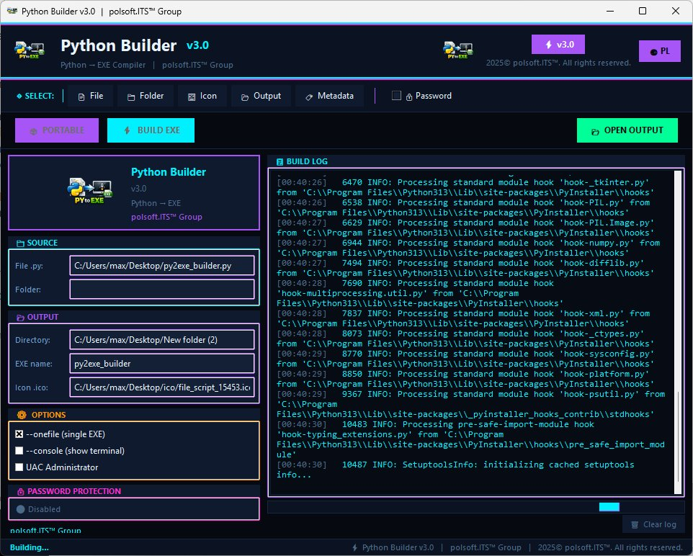
Figure 1: Python Builder v3.0 – Main Window during active build

6. Known Limitations

- Compilation time increases significantly with large dependency trees.
- Windows Defender and other antivirus solutions may flag freshly compiled executables. Consider code-signing certificates for production distribution.
- macOS and Linux targets are not supported. The application targets Windows executable output only.
- Python version must match between build machine and, if deploying without --onefile, the target machine.

7. Support and Contact

Technical Support | polsoft.its@fastservice.com
GitHub Repository | https://github.com/seb07uk
Organization | polsoft.ITS™ Group
Document Version | 1.0 – March 2025

8. License

© 2025 polsoft.ITS™ Group — Sebastian Januchowski. All rights reserved.
This software and its documentation are the exclusive intellectual property of polsoft.ITS™ Group. Unauthorized reproduction, distribution, modification, or commercial use without prior written consent is strictly prohibited.
For licensing inquiries, contact: polsoft.its@fastservice.com

